
Phone: 0800 479 7979
Address: Wheatley House, 25 Cochrane Street, Glasgow, G1 1HL

How to tell us something is wrong
A Simple Guide for Children and Young People



What is a complaint?

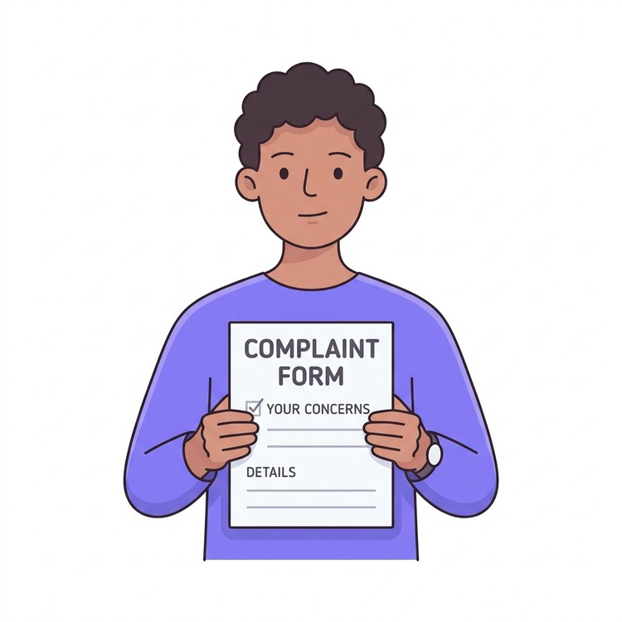 | A complaint is when you tell us something is wrong and you are not happy.

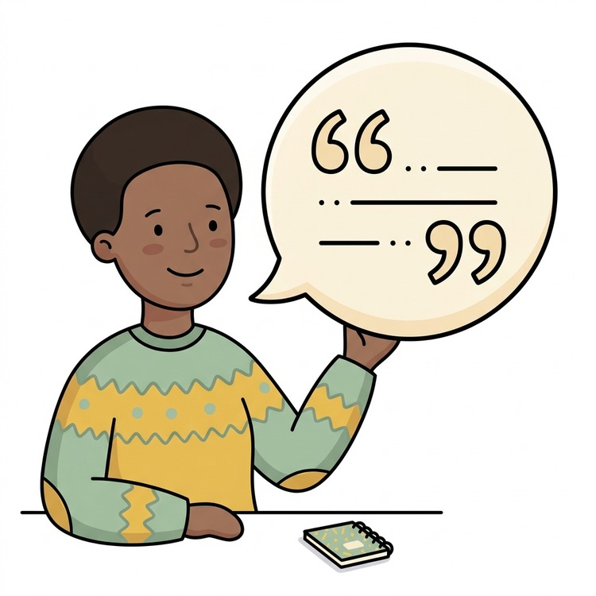 | It can be about something we have done, not done, or something we said.

 | We want to listen, help put things right, and do better next time.

Children can make complaints

 | Children and young people can complain.  You can ask someone you trust to help you.

 | This could be a parent, carer, family member, friend, teacher, or support worker.

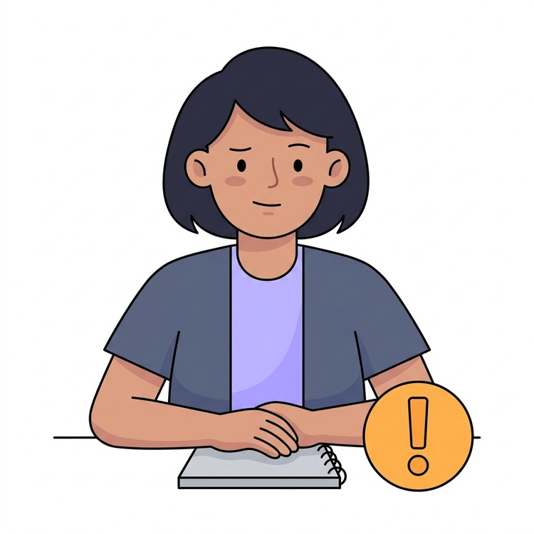 | We will listen to you and take what you say seriously.

What you can tell us about

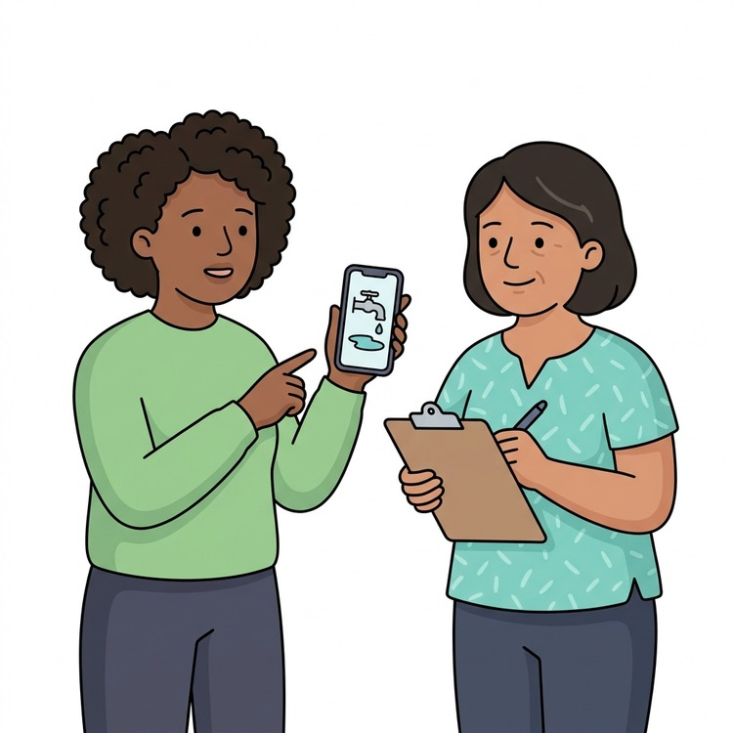 | You can complain if:  - We did not do a repair in your home properly.

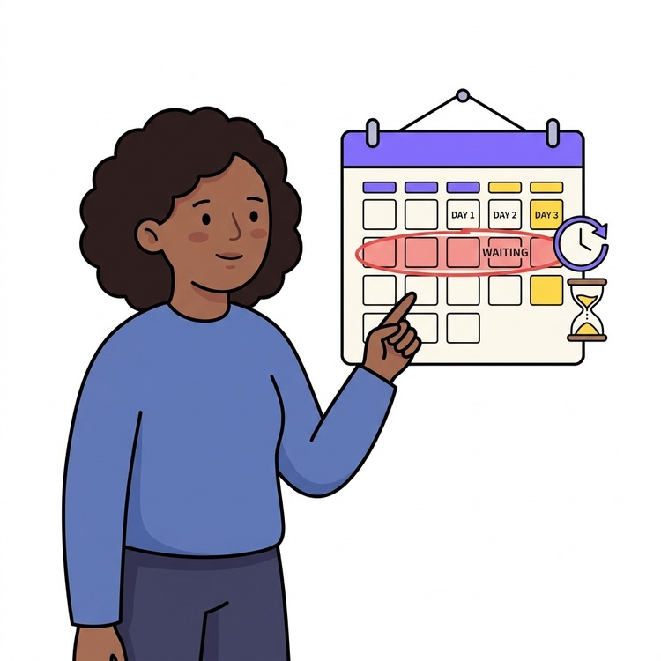 | - You have been waiting a long time for help.

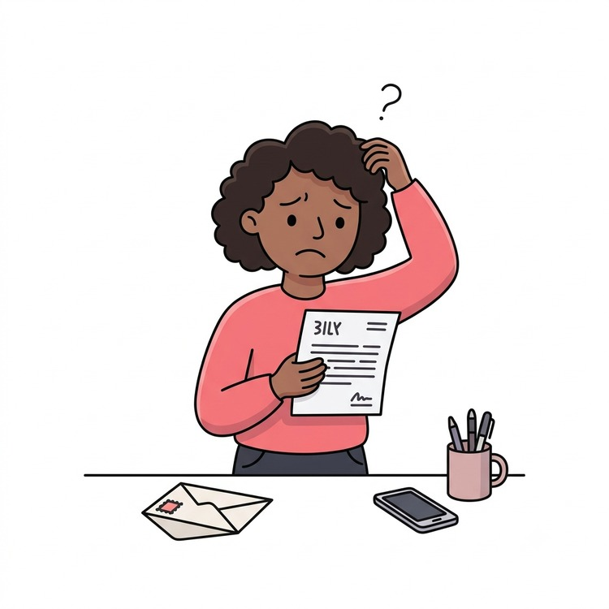 | - Someone gave you information that was confusing.

 | - You feel that someone did not treat you fairly.

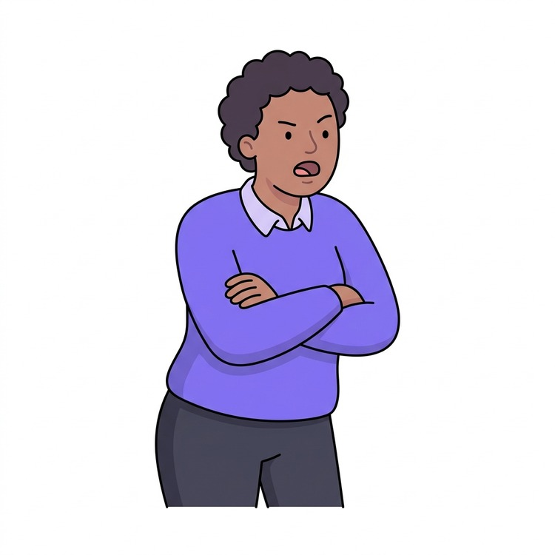 | - You are unhappy with something a member of staff did.

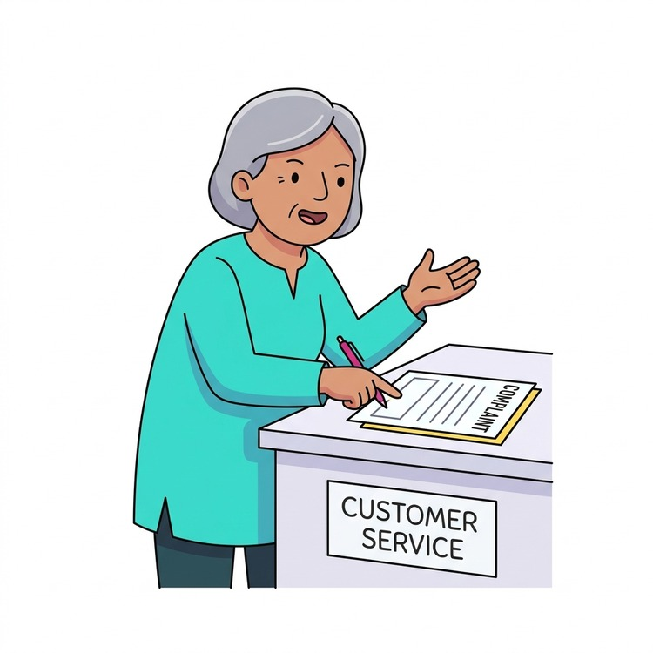 | - You are unhappy with a service that we provide.

Some things are not complaints

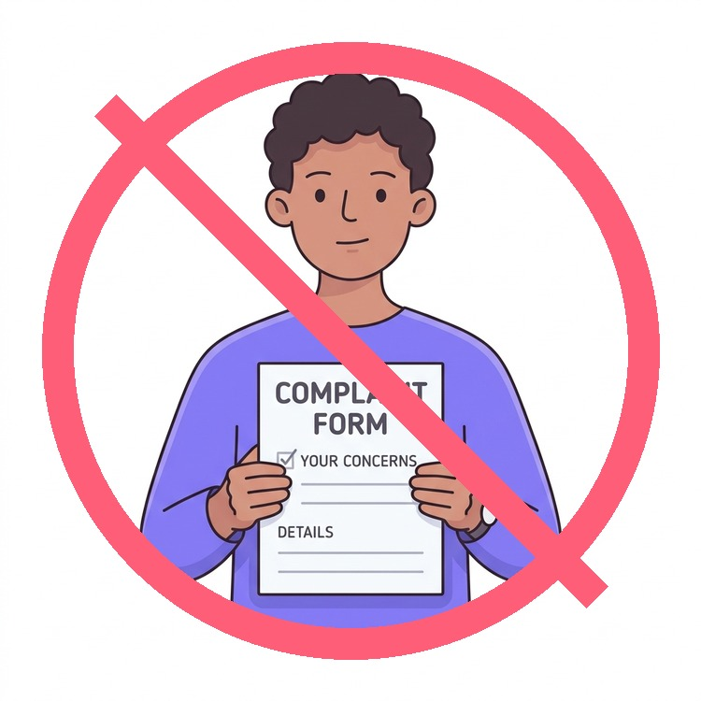 | Some things are dealt with differently.  If your problem is not a complaint, we will explain what happens next and who can help.

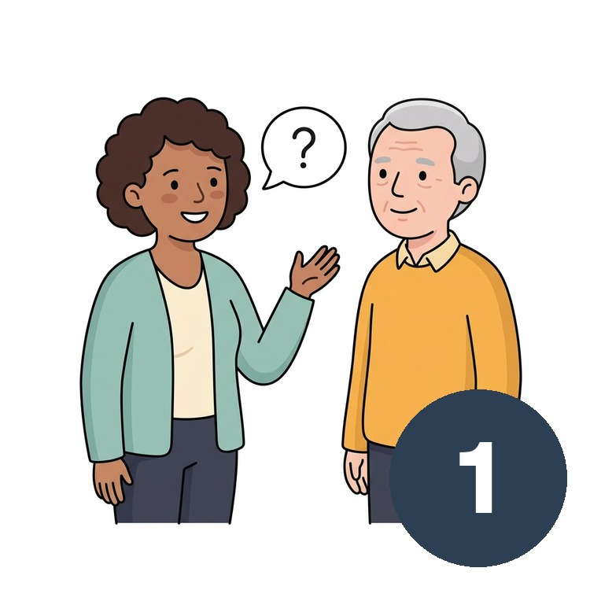 | This includes asking us to do something for the first time.

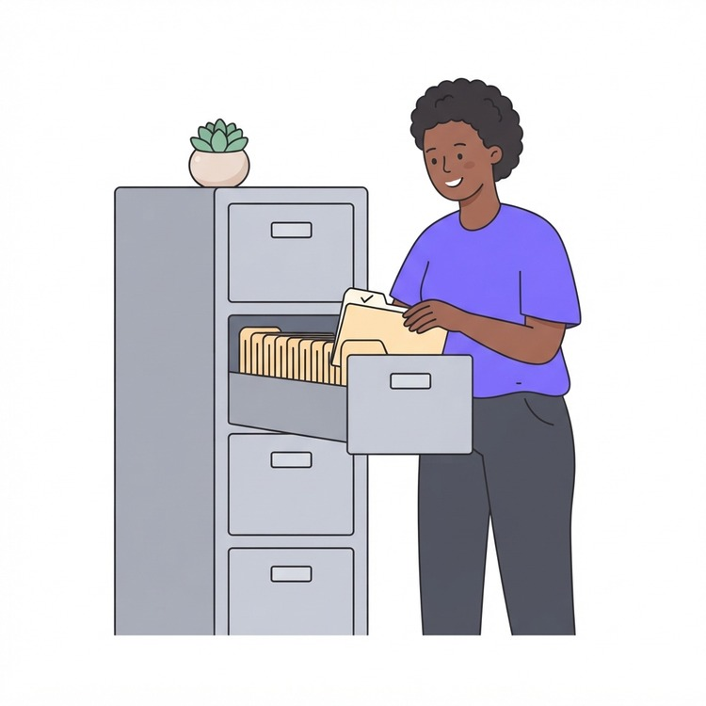 | It also includes asking to see information we have about you.

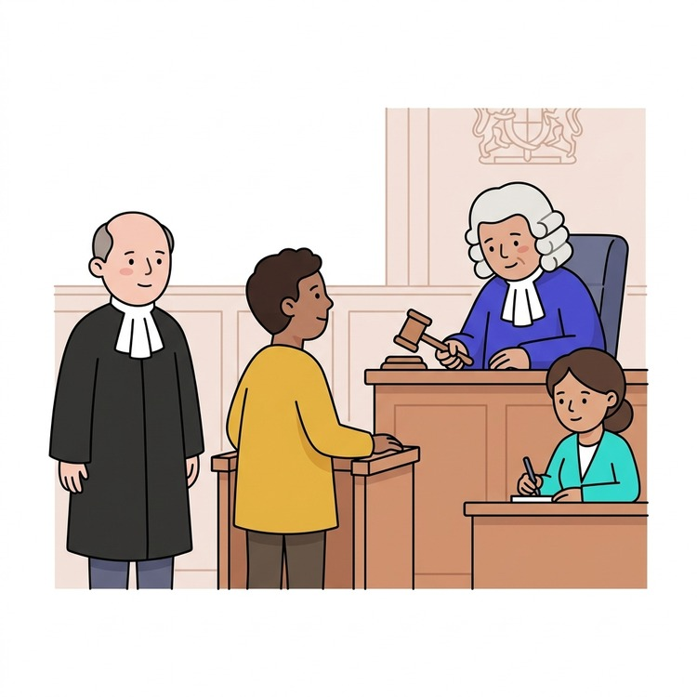 | When a court or tribunal is already looking at a problem.

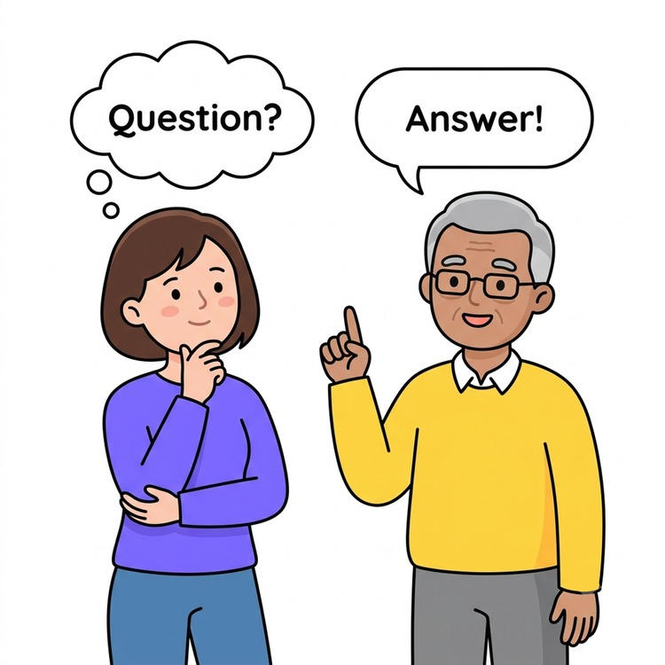 | Things we have already checked or answered are not complaints.

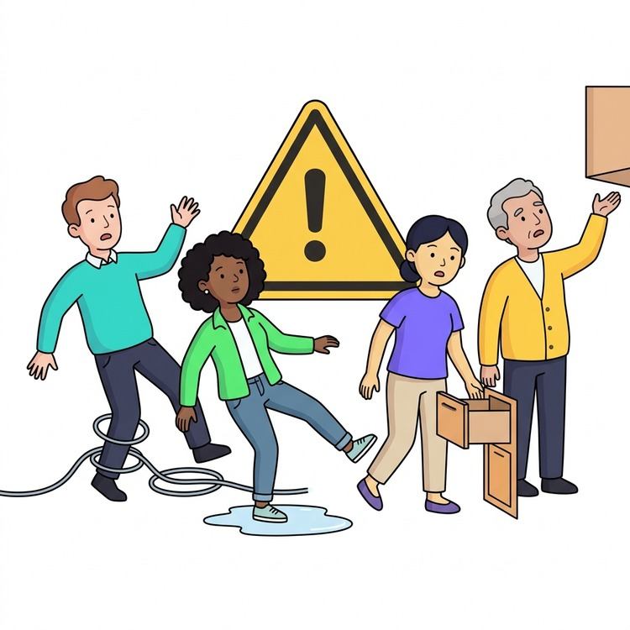 | Concerns about safety are not complaints.

How to tell us

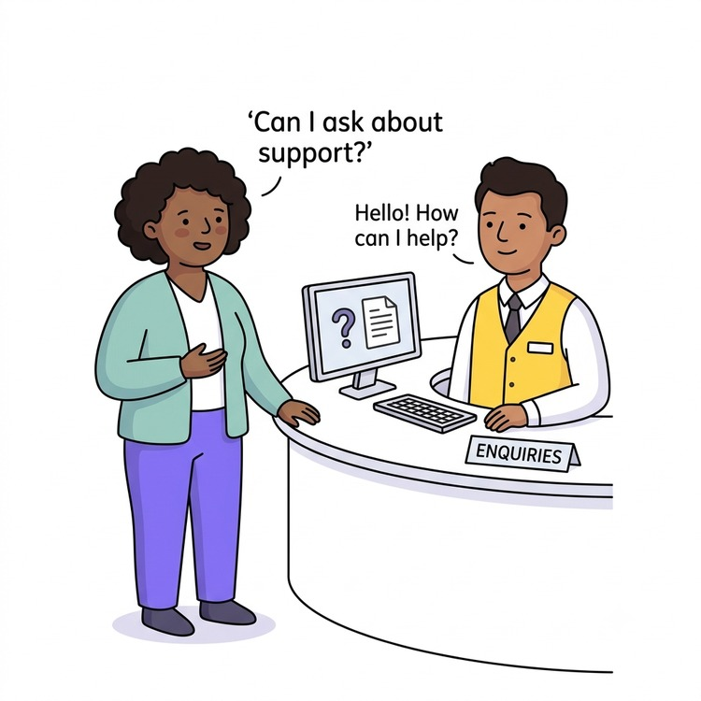 | You can talk to a member of staff.

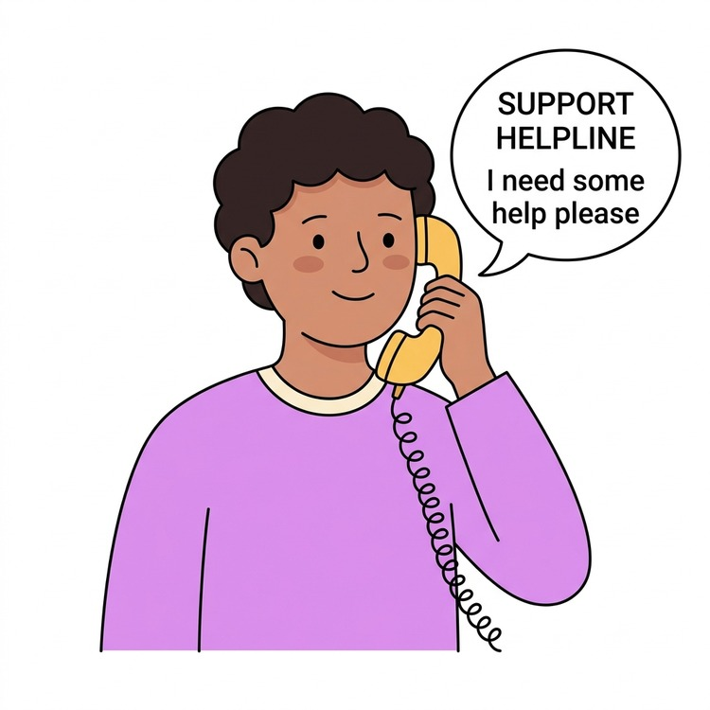 | You can phone us.

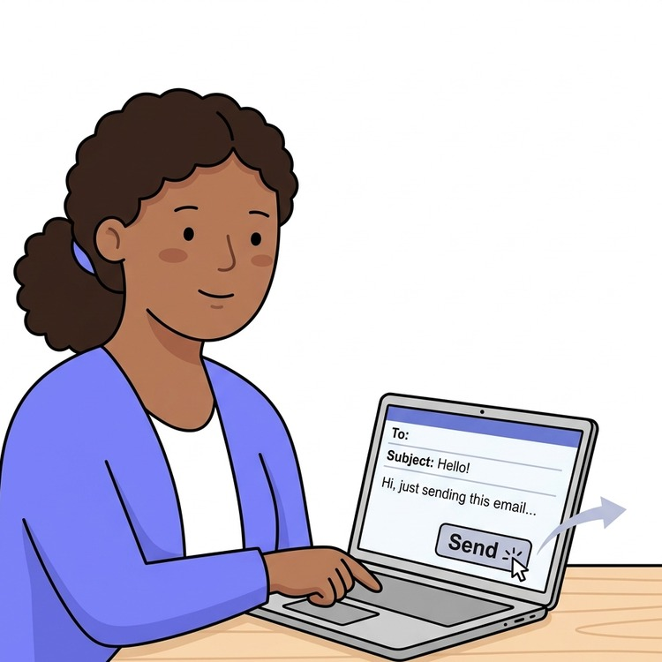 | You can email us.

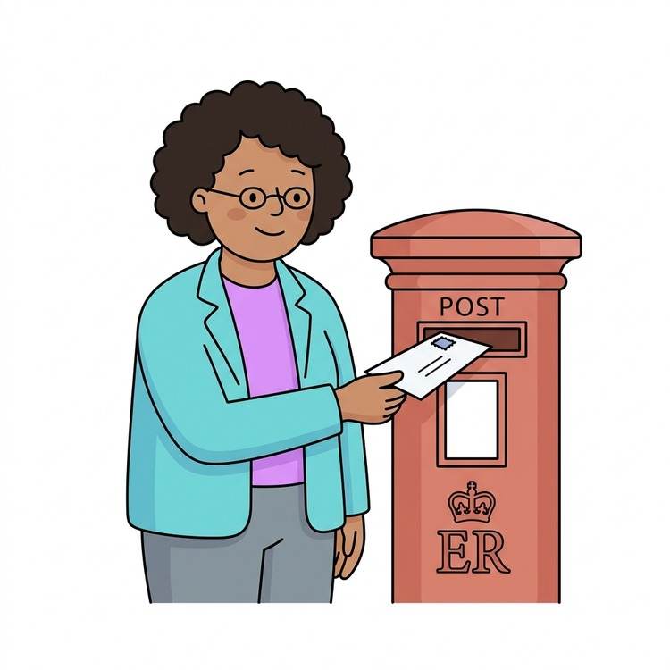 | You can write to us.

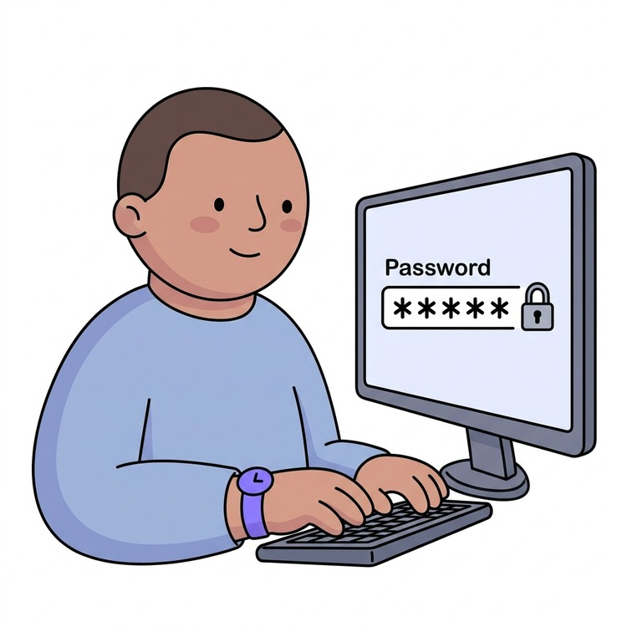 | You can use your online account.

 | It helps if you tell us your name and how to contact you.

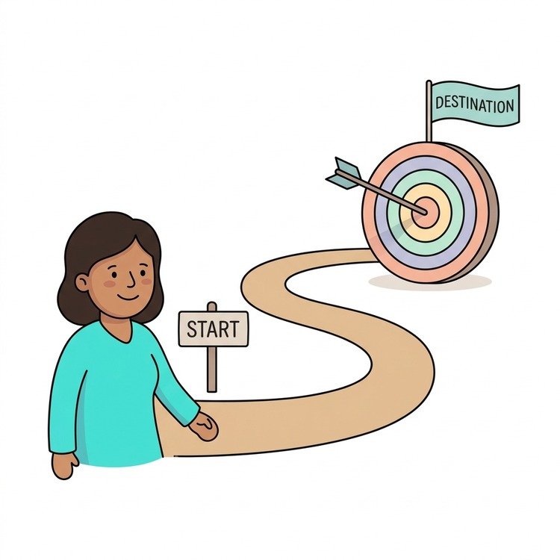 | Also tell us what happened, when it happened, and what you want to happen next.

If you feel worried or unsafe

If you feel worried, scared, or unsafe, tell an adult you trust.

This could be a parent, carer, teacher, support worker, or housing officer.

What happens after you complain

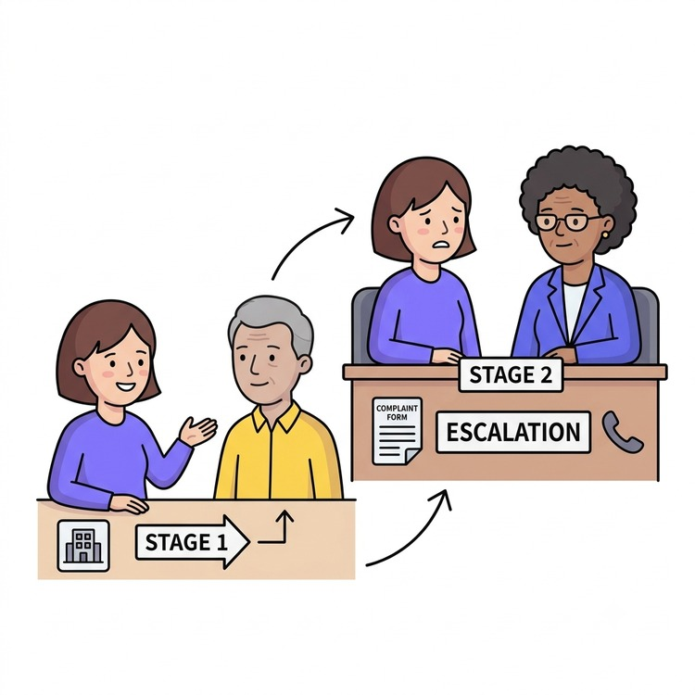 | There are two steps when we deal with a complaint.

 | Stage 1: We will try to fix your complaint quickly.

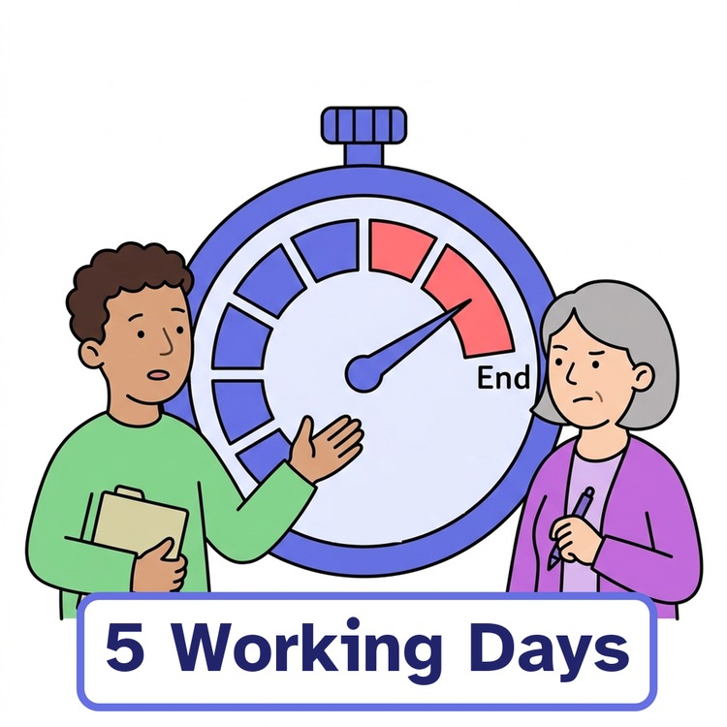 | We usually answer within five working days.

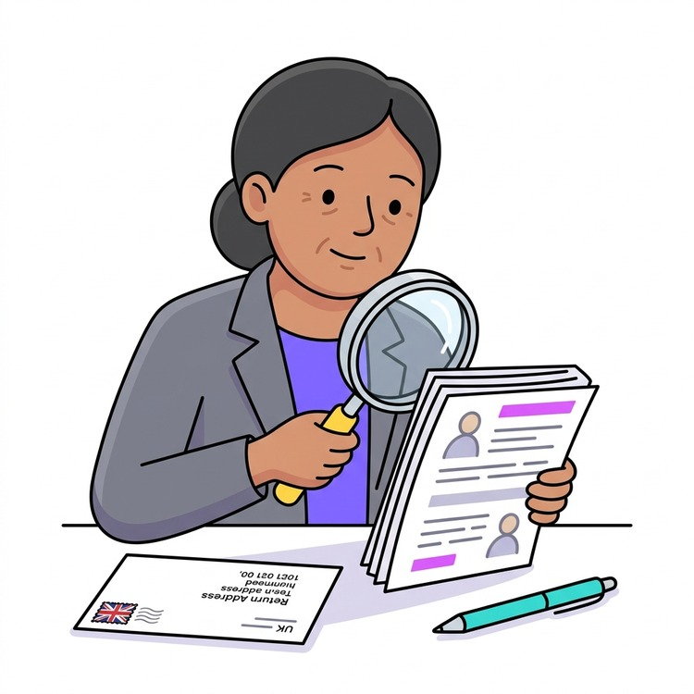 | Stage 2: If we need to, we will take a closer look.

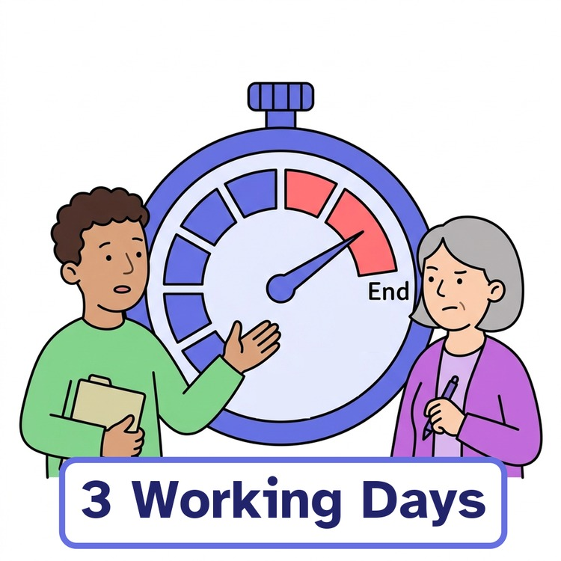 | We will tell you we got your complaint within three working days.

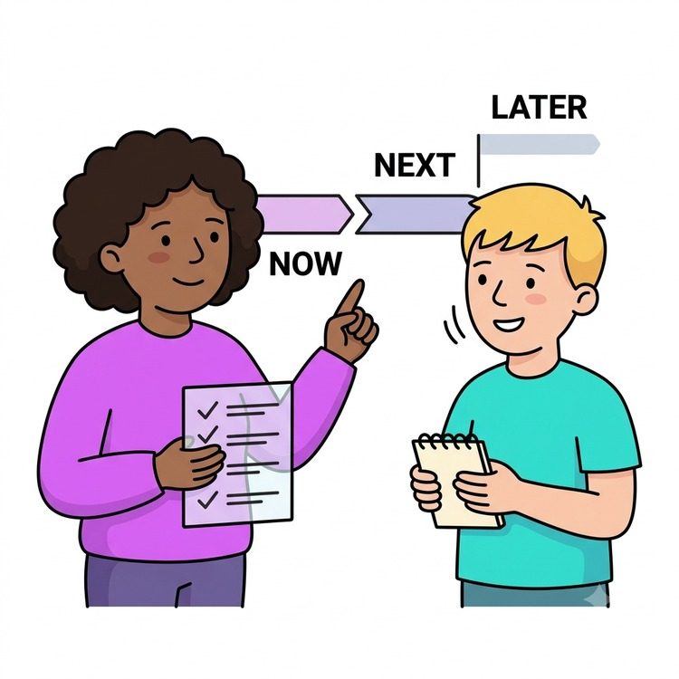 | We will explain what we will look at and keep you updated.

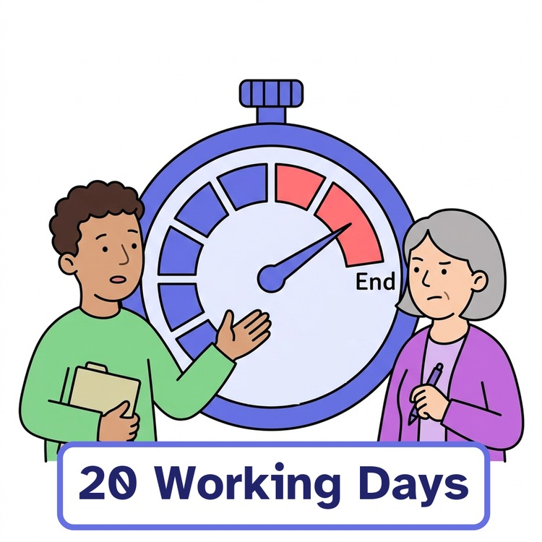 | We usually give our final answer within 20 working days.

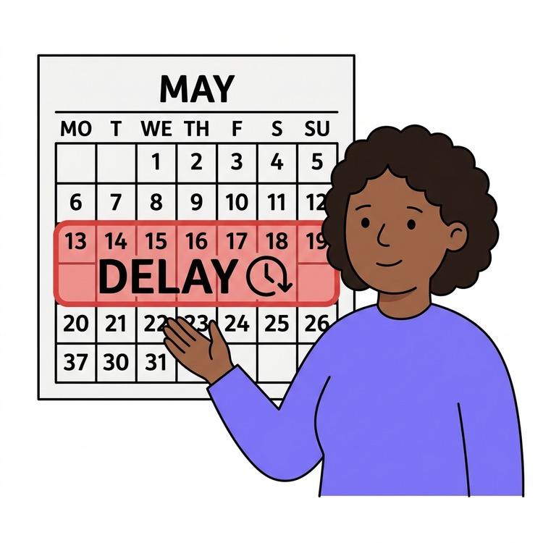 | If we need more time, we will tell you why.

If you still feel unhappy

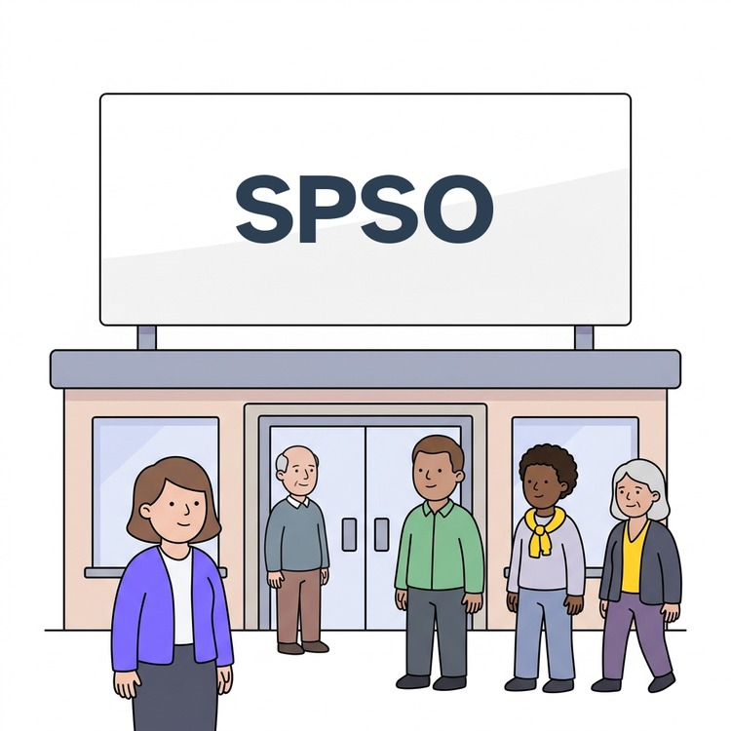 | If you are still unhappy, you can ask the Scottish Public Services Ombudsman (SPSO) to help.

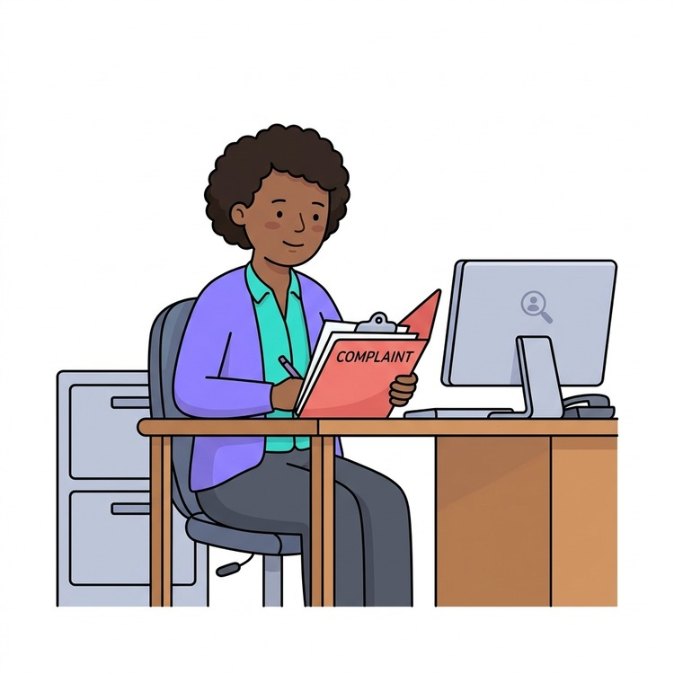 | The SPSO is an independent organisation that can look at your complaint.

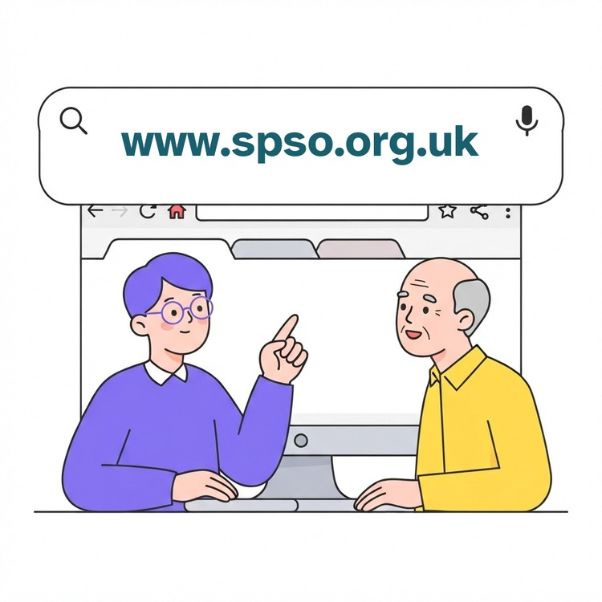 | The SPSO's website is www.spso.org.uk.  Or you can phone them for free on 0800 377 7330.

Someone can help you

 | You do not have to make a complaint on your own.

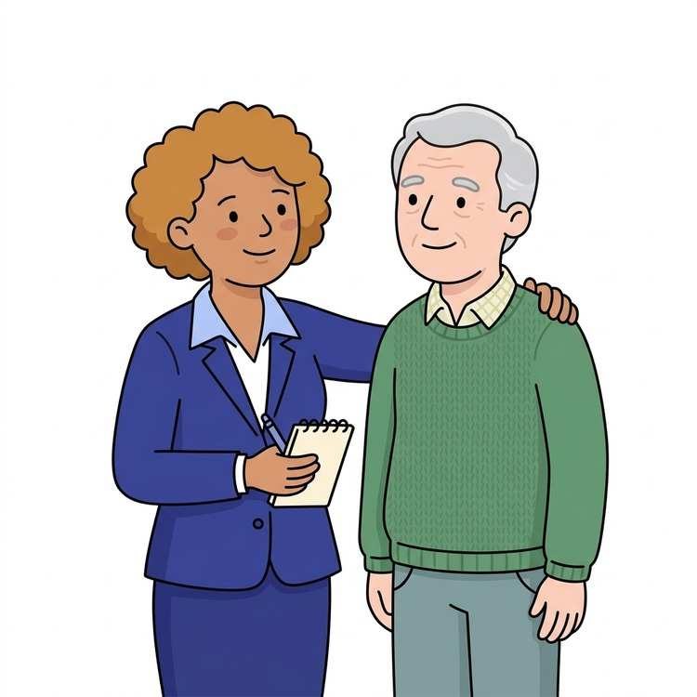 | You can ask someone you trust or an advocate to help you.

 | An advocate can help you explain what happened.  They can stand up for you.

 | Citizens Advice Scotland or an advocacy group may also help.

Good to remember
Your voice matters, and we will listen.
We will try to help and use what you tell us to get better.

How to contact us

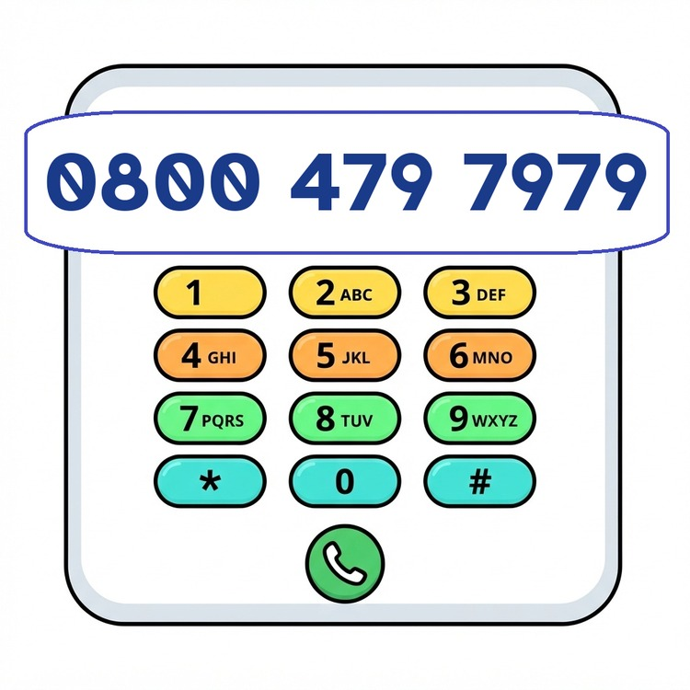 | Phone: 0800 479 7979

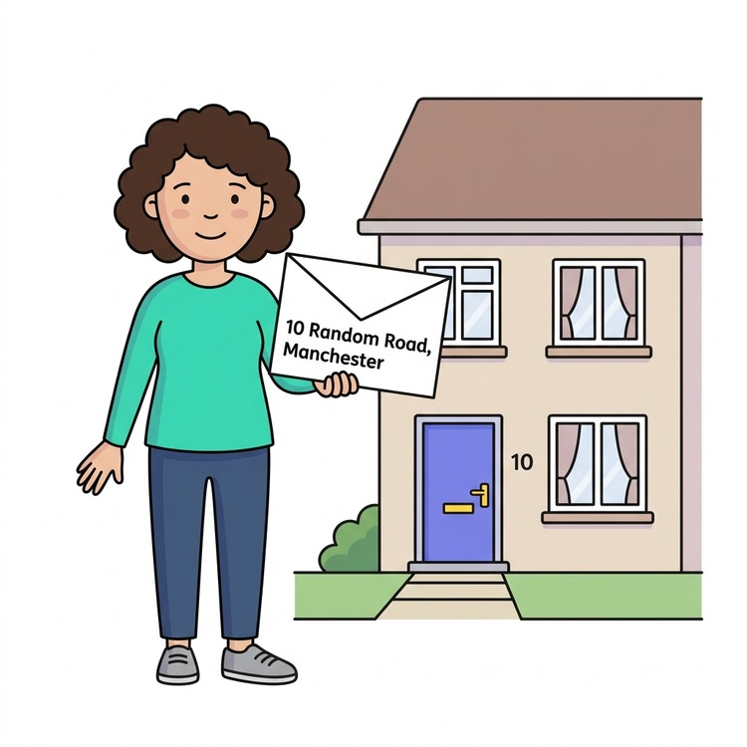 | Address: Wheatley House, 25 Cochrane Street, Glasgow, G1 1HL

Pictures by Claru or in the public domain unless otherwise stated.

